# CS 340 README

**Rescue Animals Management System (RAMS)**

## About the Project/Project Title

Grazioso Salvare, an innovative international rescue-animal training company, wants to create a software application to maintain animal shelter data and categorize dogs based on training criteria. This application contains a front-end module to show the dashboard of animals and is also used to manage animal data. Animal data is handled in a database for persistence.

## Motivation

This application helps Grazioso Salvare to find suitable dogs based on some criteria-based search for rescue training. Using the CRUD feature, they can easily create a new animal record, update the existing animal record, read the animal details, and delete any animal records that are no longer available.

Another primary motivation is that this application will be created as open source, and the source code will be available on GitHub for other companies needing it.

## Getting Started

*Follow the steps to run RAMS locally.*

1. *Clone RAMS source code from GitHub link* [*https://github.com/graziososalvare/rescue-animals-management-system*](https://github.com/graziososalvare/rescue-animals-management-system)
2. *Create an environment using conda,*

*conda create --name rescue-animals-management-system python=3.12*

*source activate rescue-animals-management-system*

1. *Install required packages using below command*

*pip install -r requirements.txt*

1. *Launch the app using*

*python rams_app.py*

## Installation

*Install the latest RStudio IDE from https://posit.co/downloads/ for Python code editor and run the application locally.*

*Install Jupyter Notebook from* [*https://jupyter.org/install*](https://jupyter.org/install) *for computation needs.*

## Tools:

Mongo DB: This NoSQL database is open source and can handle the requirements for developing this application. It comes with a database client that can be used to perform CRUD operations.

Dash Framework: This popular and simple web-based framework is a great fit for Python web applications.

**Challenges**:

* The Jupyter Notebook session is timing out without clear notification, which is hard to find and causes confusion because code changes are not reflected properly. To overcome this issue, a regular kernel restart or closing the browser and opening a new window is required.
* Another challenge is to make dashboard visualization dynamic depending on the screen size or settings. Proper style settings with height, width, mode, etc., help achieve this feature.

## Usage

### Code Example

1. To connect Mongo DB using pymongo package from pymongo import MongoClient

self.client = MongoClient('mongodb://%s:%s@%s:%d' % (USER,PASS,HOST,PORT))

self.database = self.client['%s' % (DB)]

self.collection = self.database['%s' % (COL)]

1. *Code to insert new animal record.*

def create(self, data):

''' Method to insert animal record '''

try:

results = self.collection.insert_one(data)

return True if results.inserted_id else False

except Exception as e:

print(f"Error inserting document: {e}")

return False

1. Code to read animal records.

def read(self, query):

''' Method to read animal record '''

try:

cursor = self.collection.find(query)

return list(cursor)

except Exception as e:

print(f"Error quering documents: {e}")

return []

1. Code to update animal records.

def update(self, query, new_data):

''' Method to update animal records '''

try:

result = self.collection.update_many(query, {'$set': new_data})

return result.modified_count

except Exception as e:

print(f"An error occured in update operation: {e}")

return 0

1. Code to delete animal records.

def delete(self, query):

''' Method to update animal records '''

try:

result = self.collection.delete_many(query)

return result.deleted_count

except Exception as e:

print(f"An error occured in delete operation: {e}")

return 0

### Tests

*Use pytest and pep 8 packages to test python code. For example,*

***py.test --pep8 acc_crud.py***

### Screenshots

1. importing a CSV file using the appropriate MongoDB import tool.

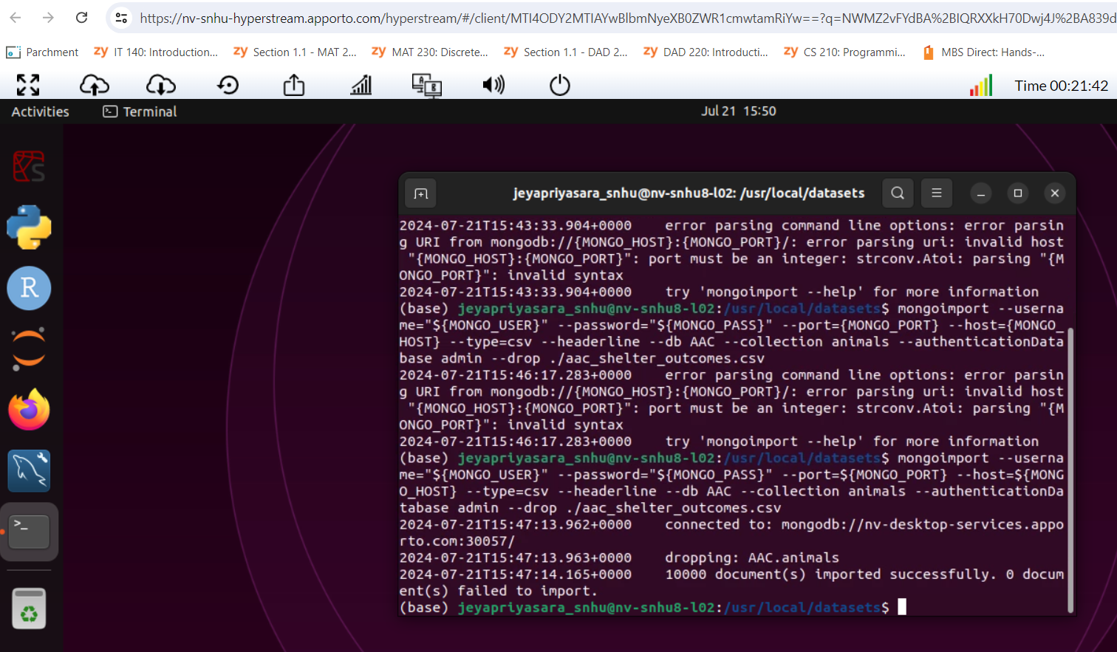

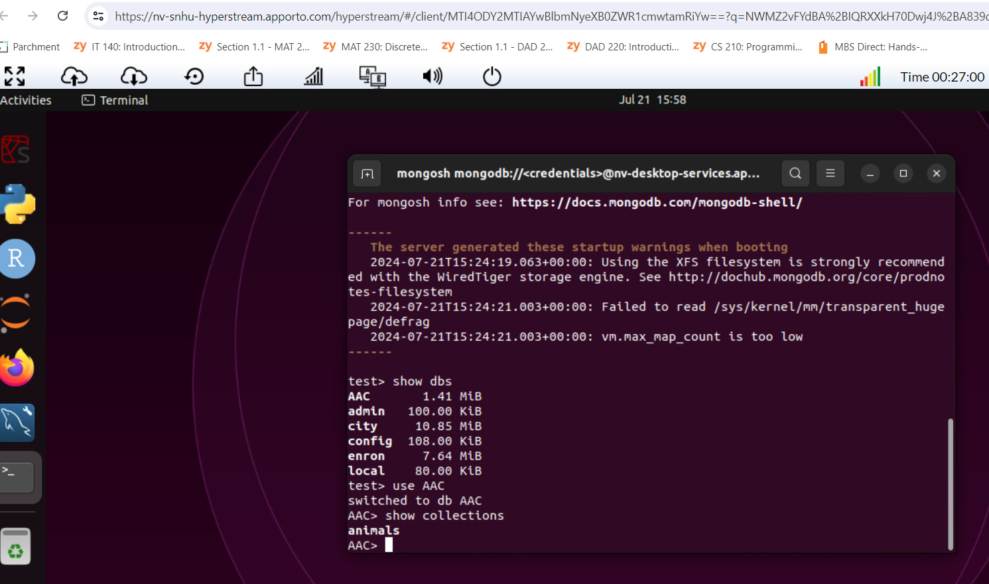

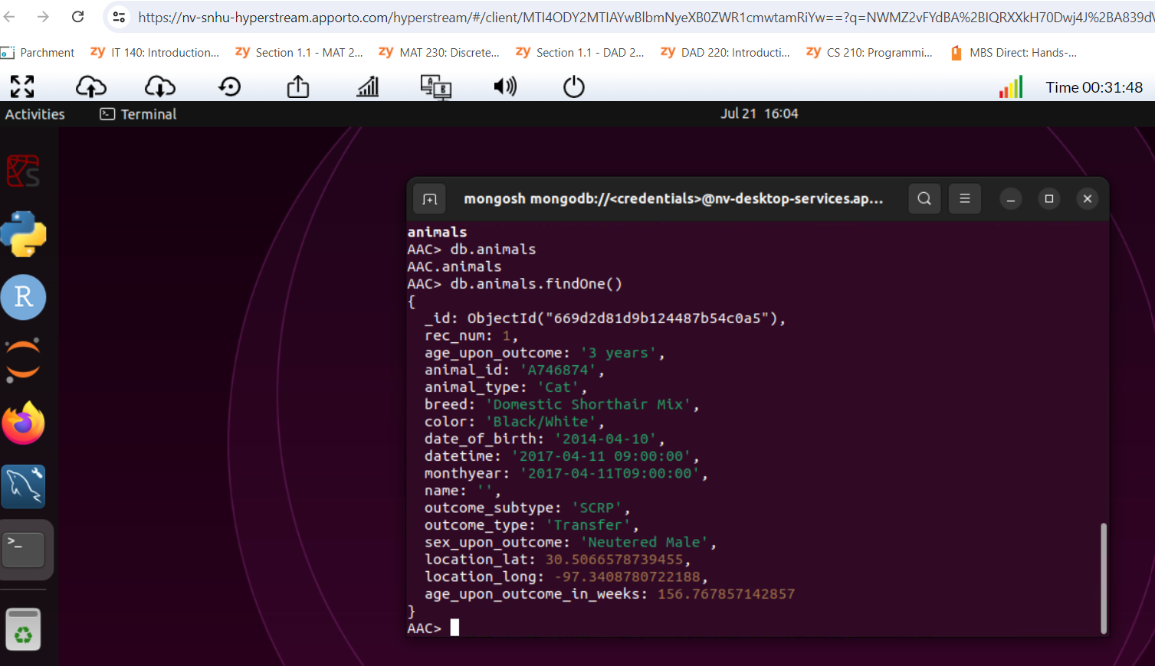

1. Create a new user account called “aacuser” for the database AAC in the mongo shell.

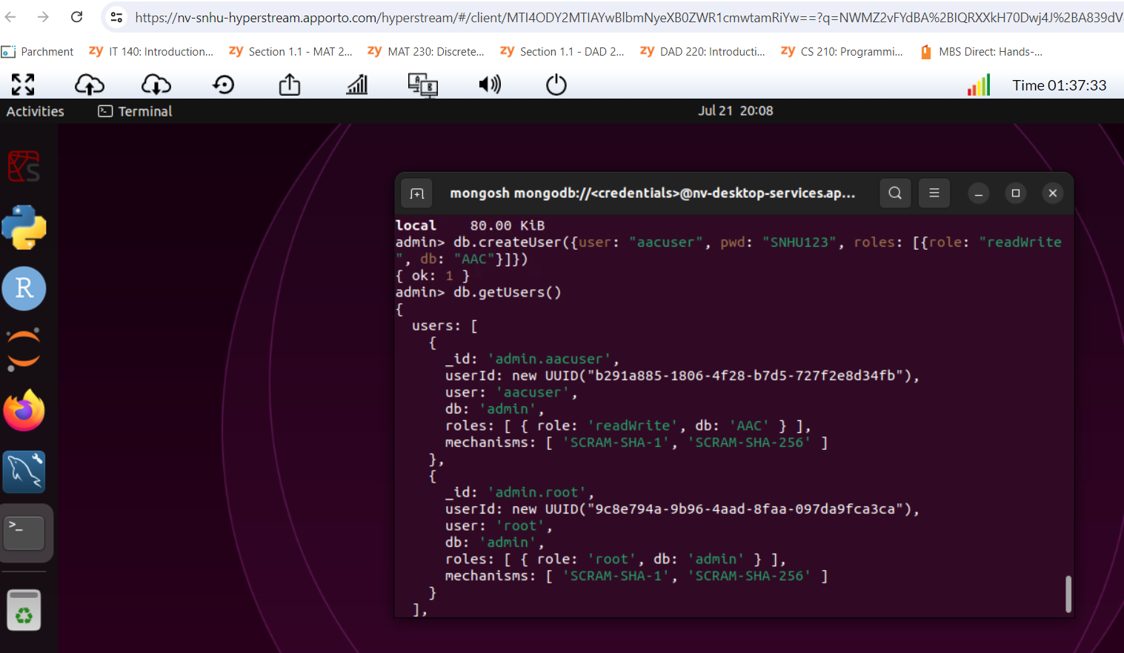

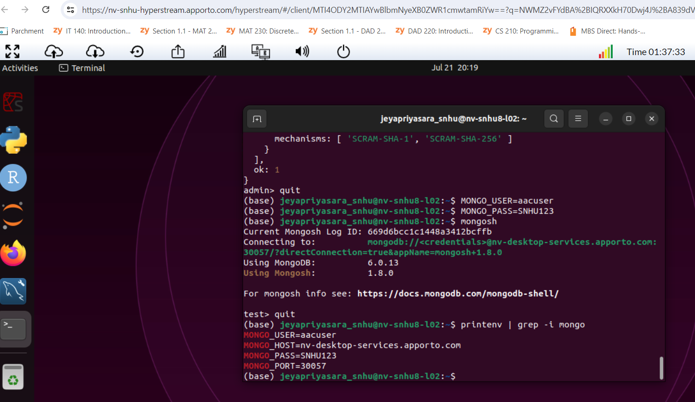

db.runCommand({connectionStatus:1})

Shows connected user is “aacuser”

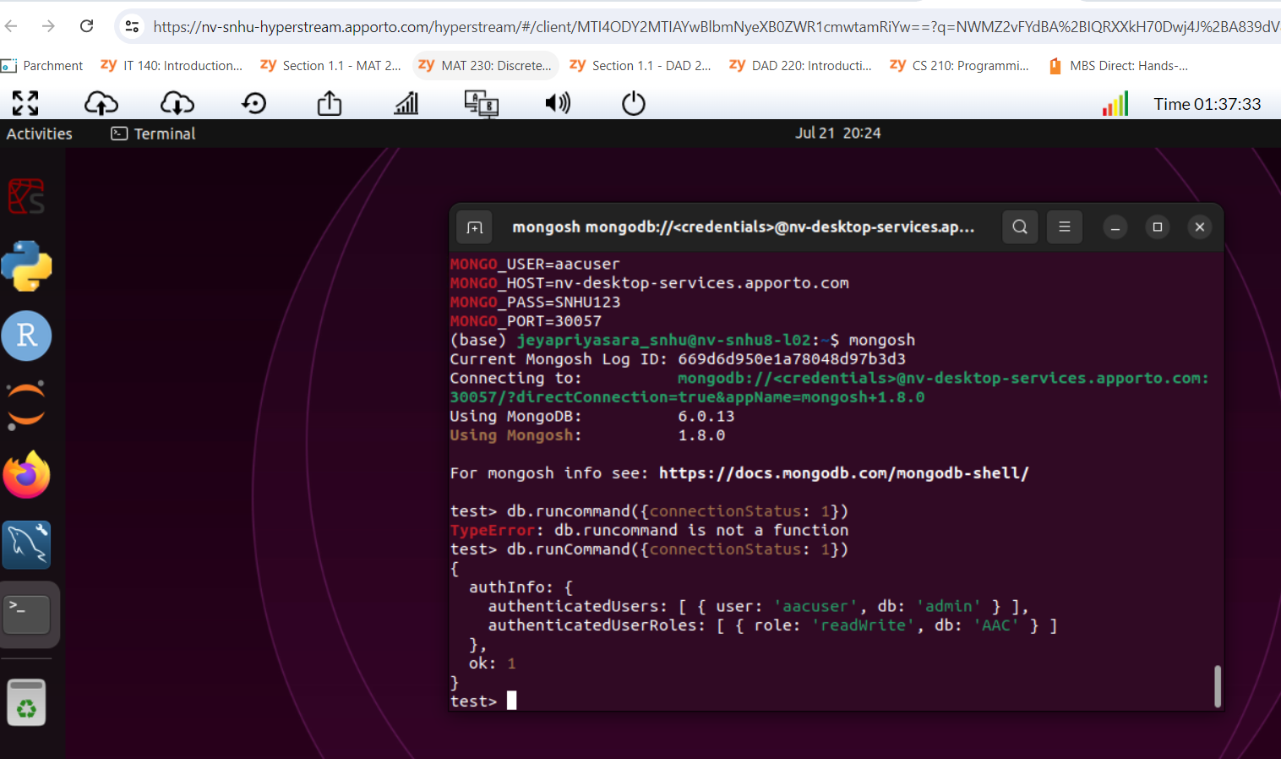

1. *Import and Connect Mongo DB*

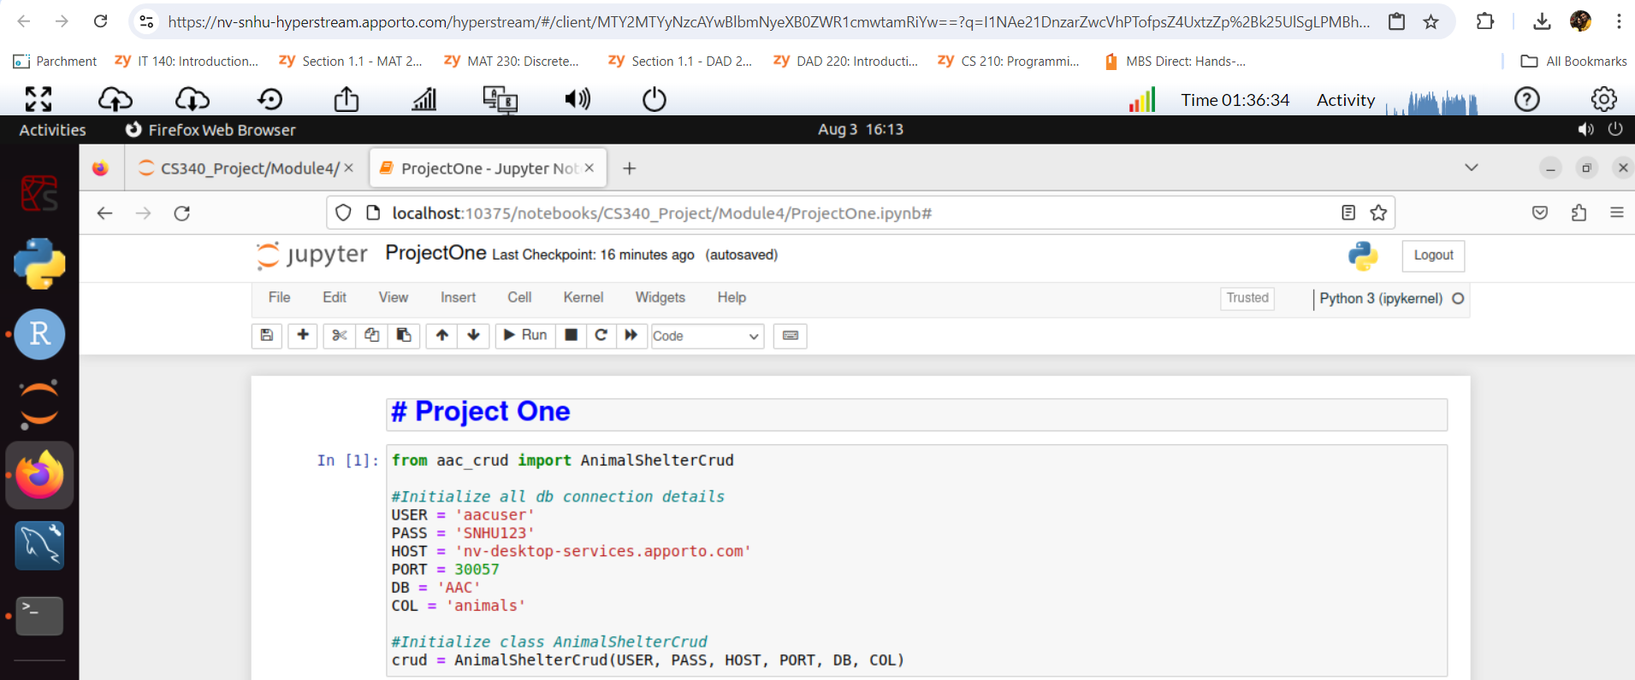

Insert new animal record and read – Successful

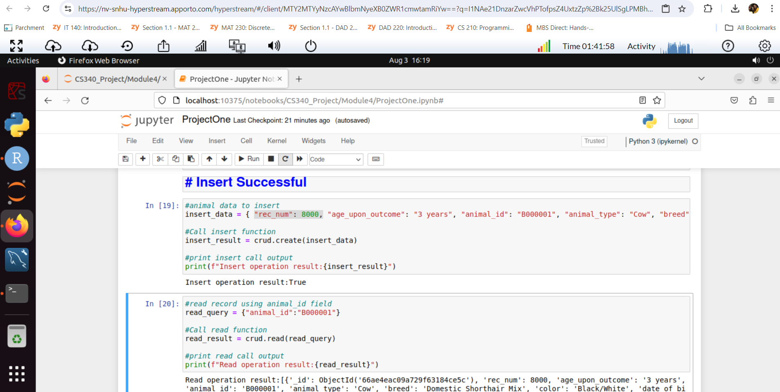

Insert new animal record – Failure

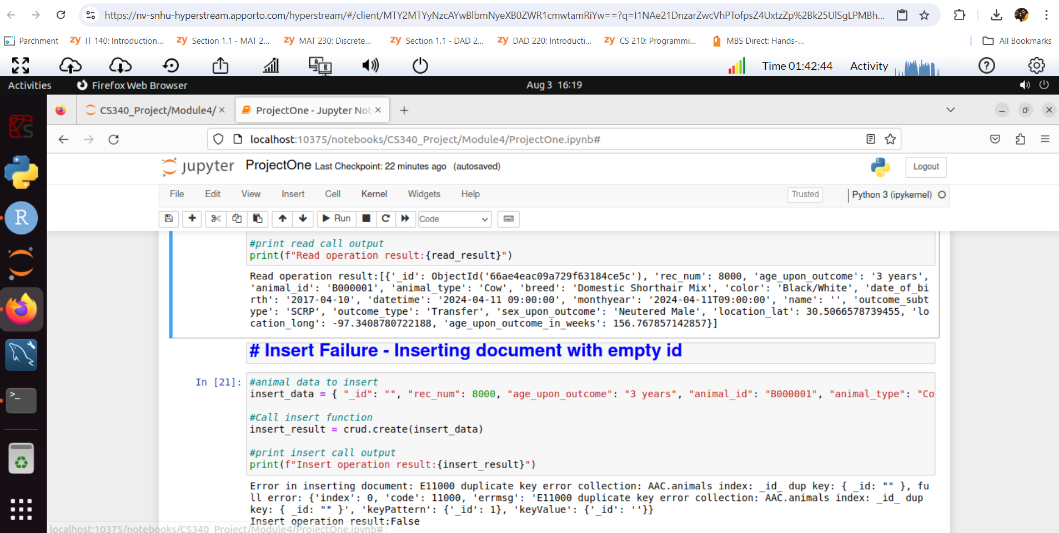

Update existing animal record - Successful

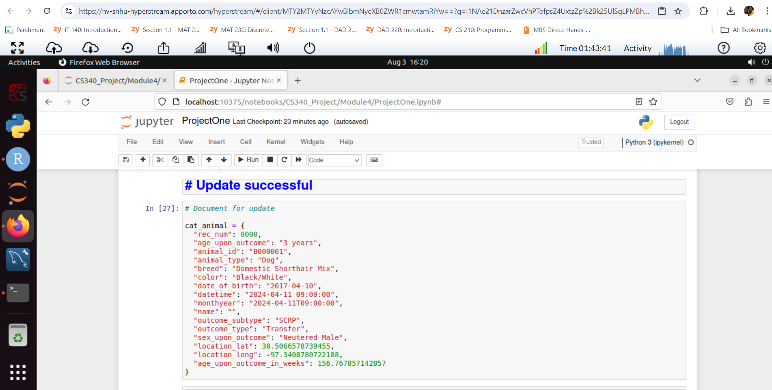

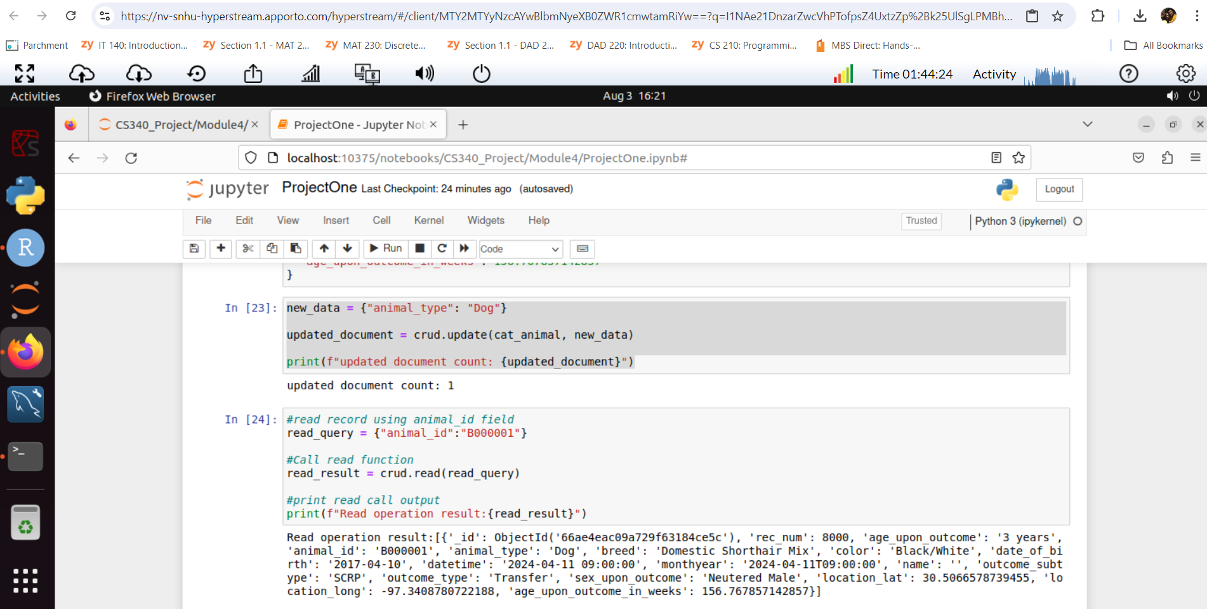

Update document - Failed

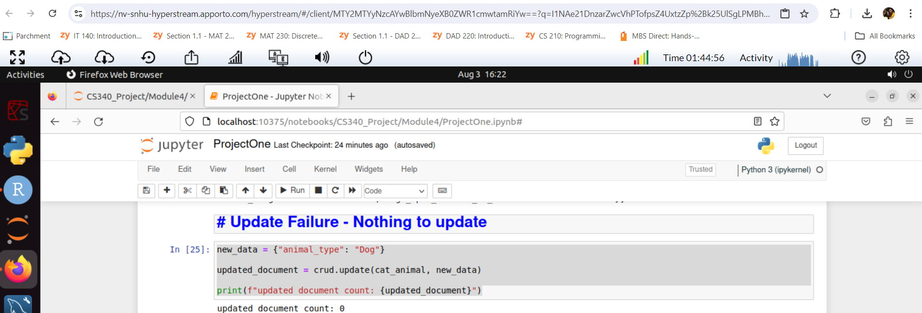

Delete document - Successful

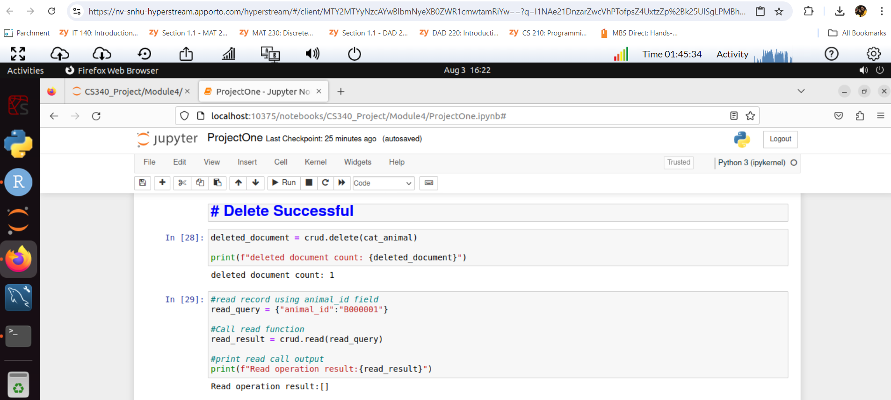

Delete document – Failed

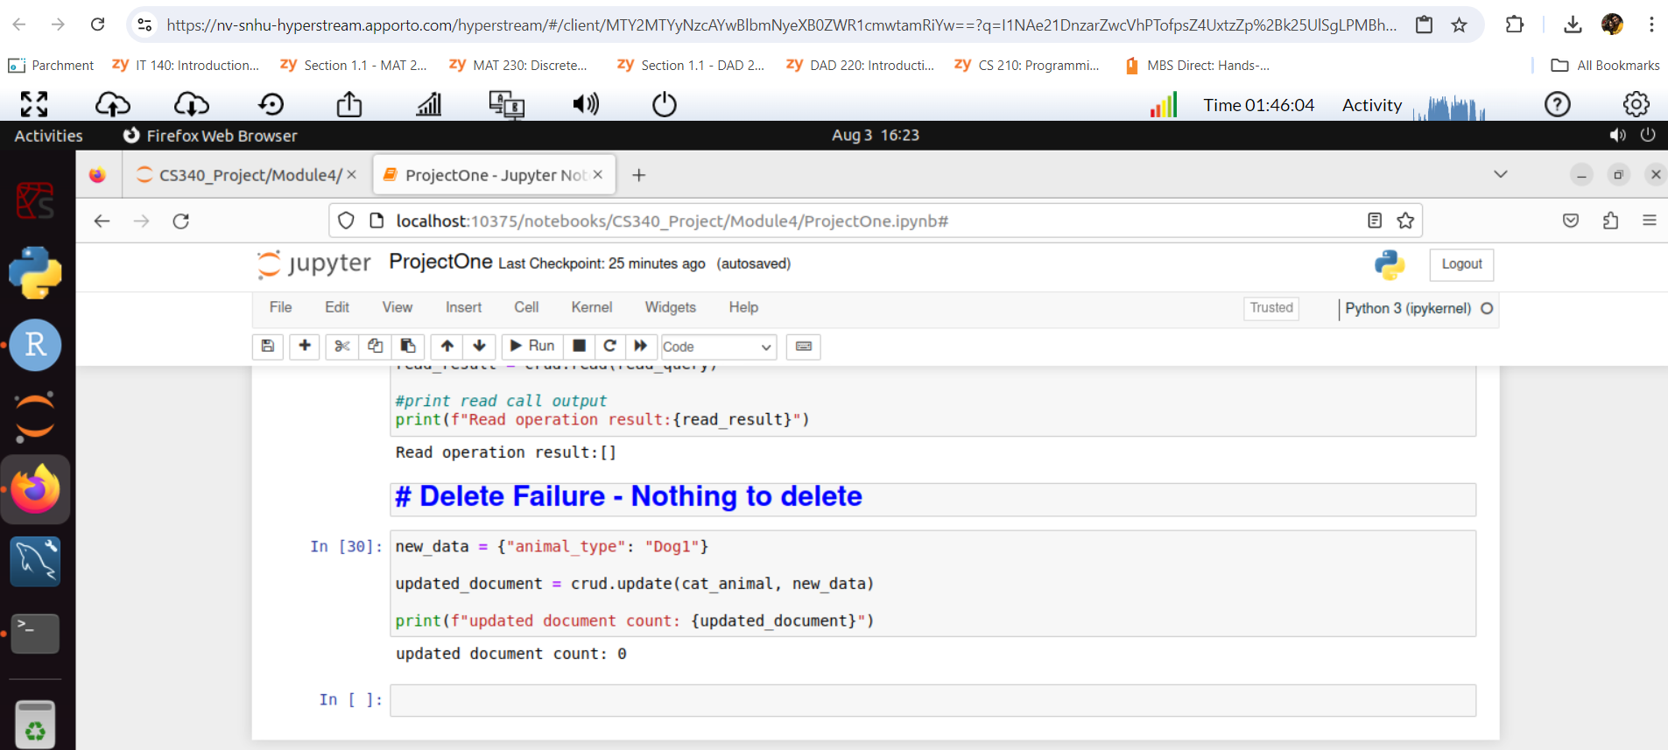

Dashboard Creation Code

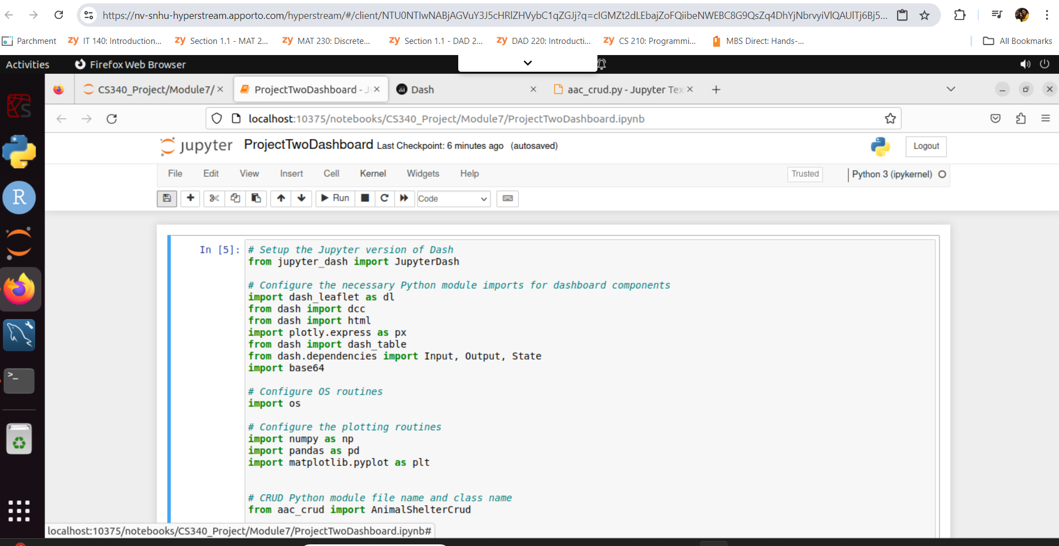

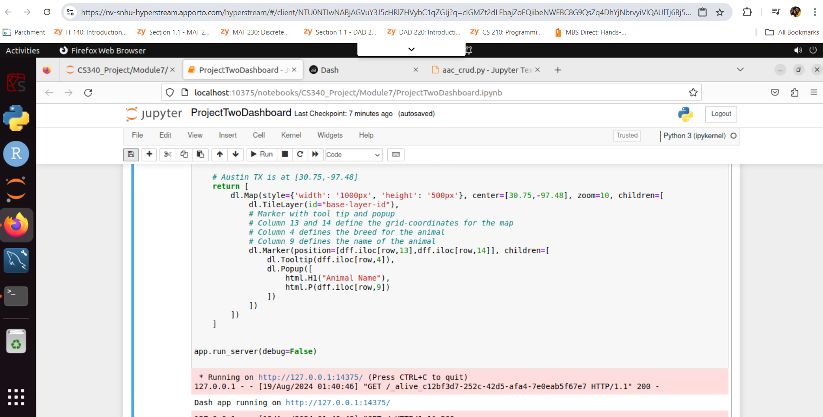

Run Dash app to see animal shelter dashboard

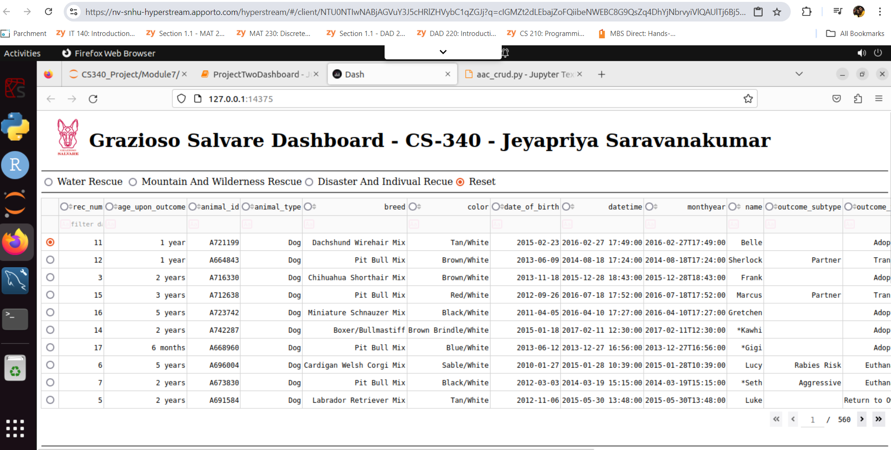

Water Rescue – Filter

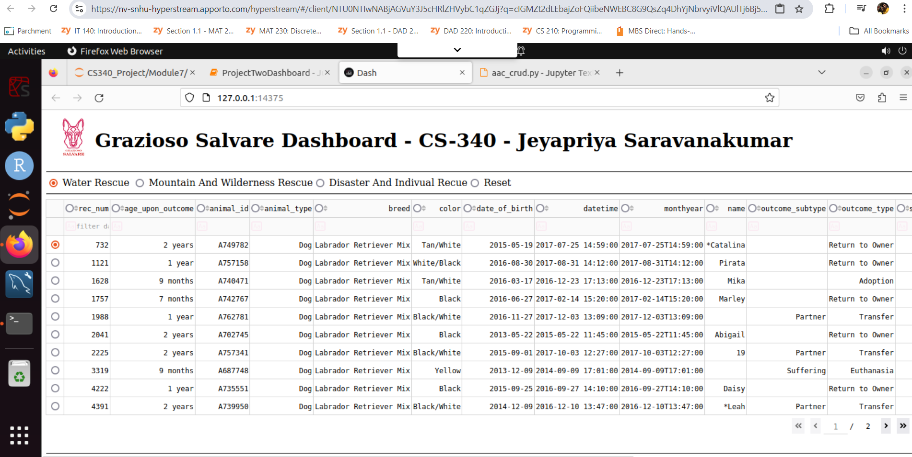

Pie chart show dashboard results with legend

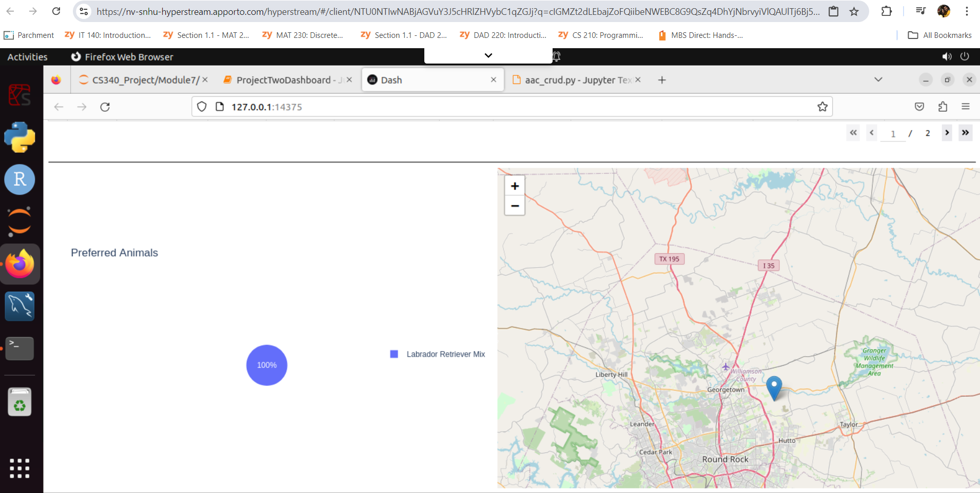

Mountain and Wilderness Rescue - Filter

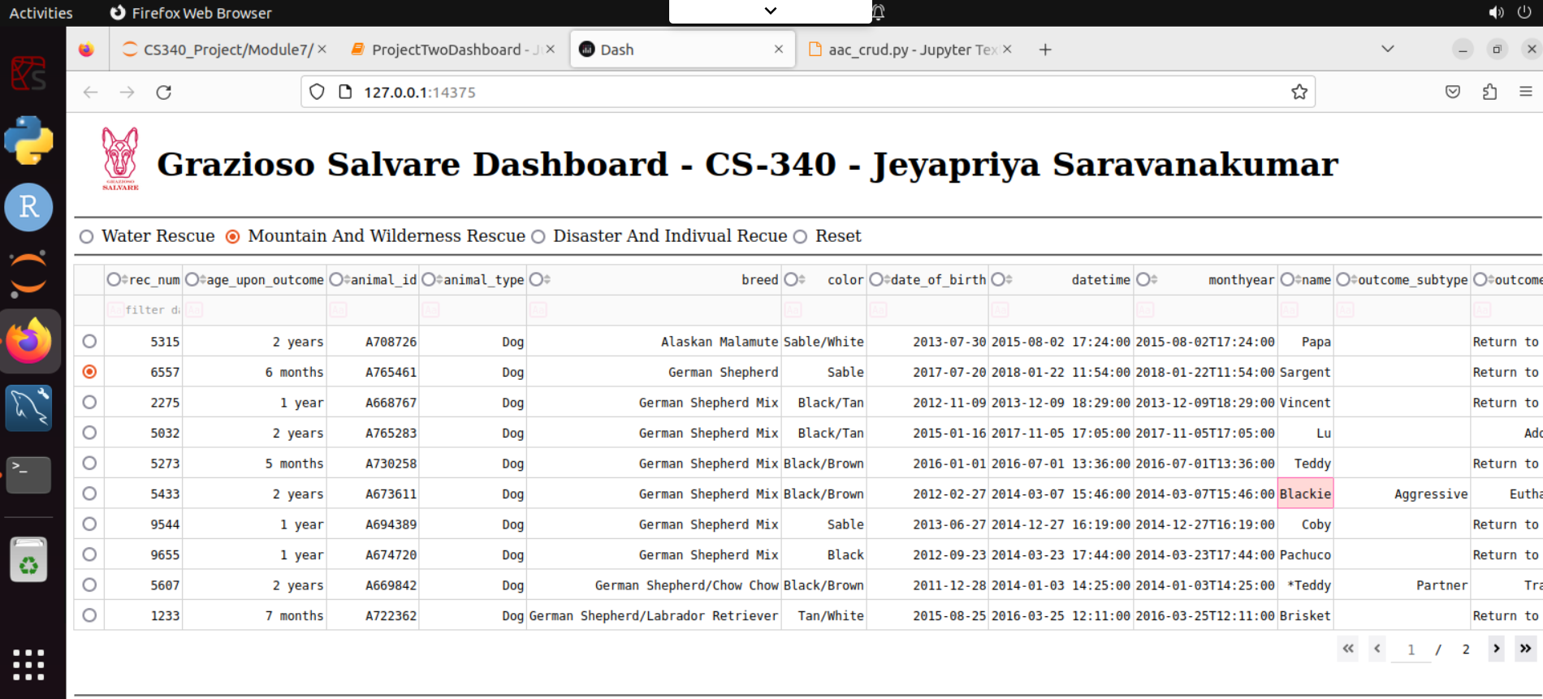

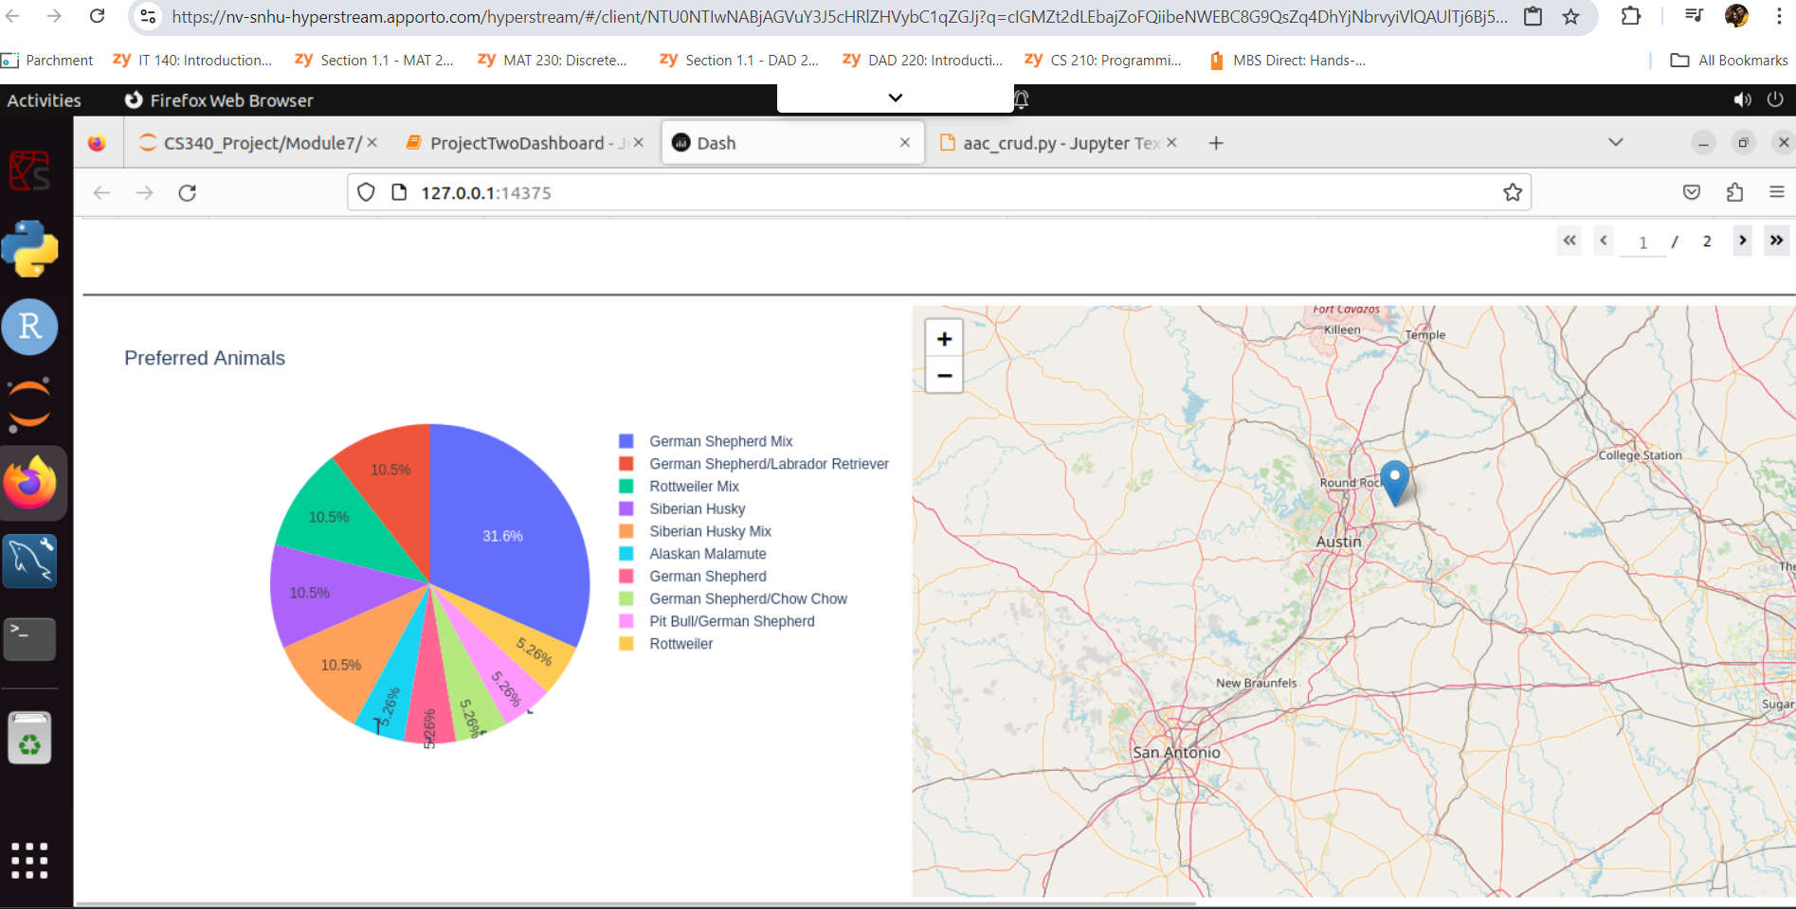

Disaster Rescue - filter

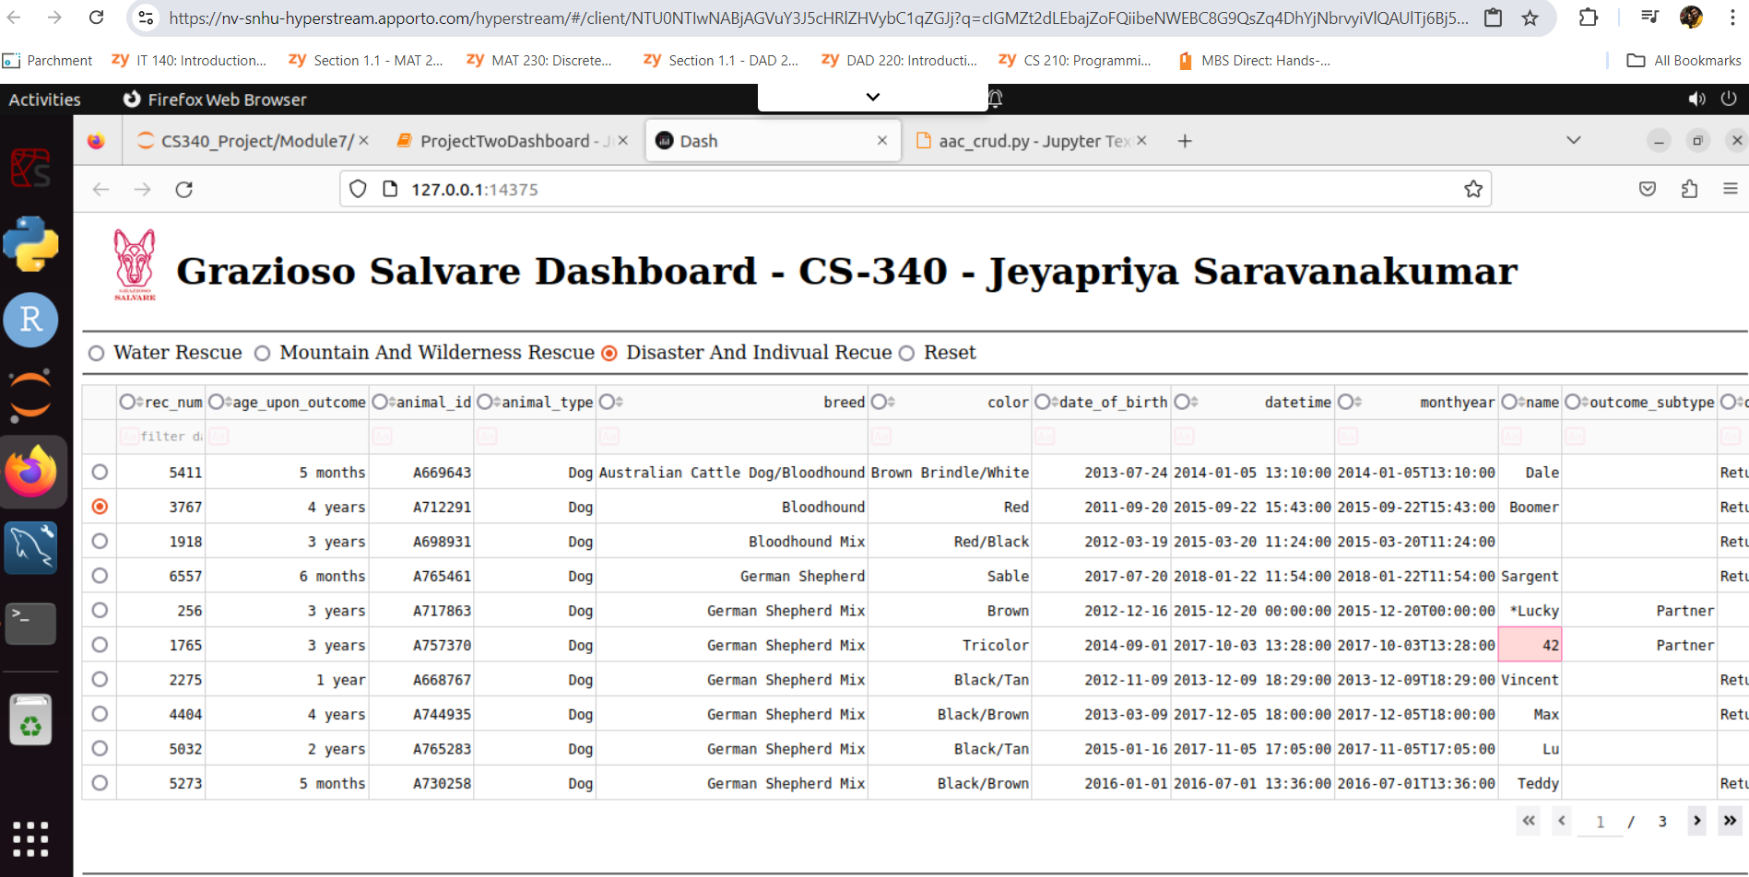

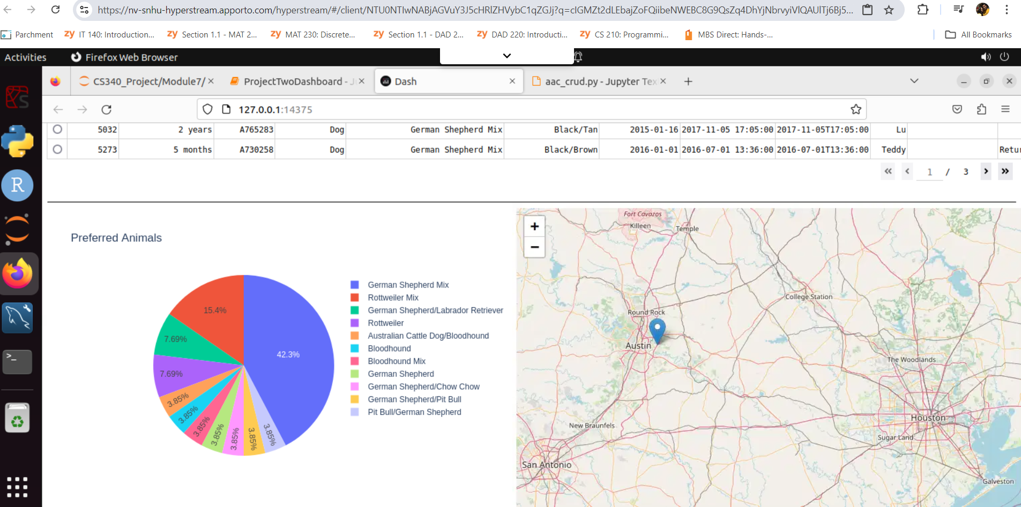

Reset – Filter to set original data

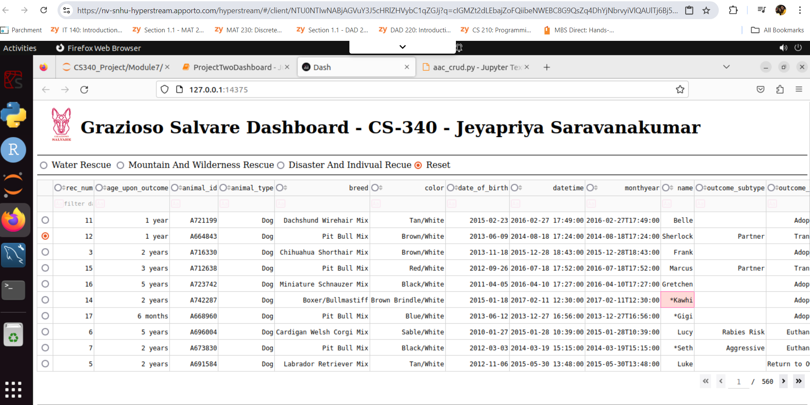

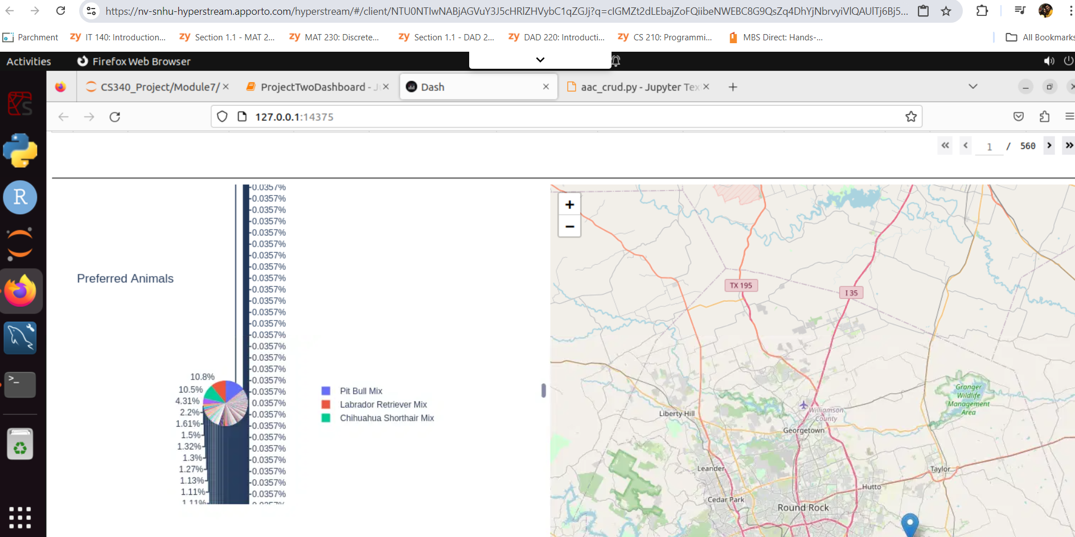

## Contact

Jeyapriya Saravanakumar